  SCH Presents a  2-Day workshop featuring  Hoang Dao  August 15-16, 2026 | 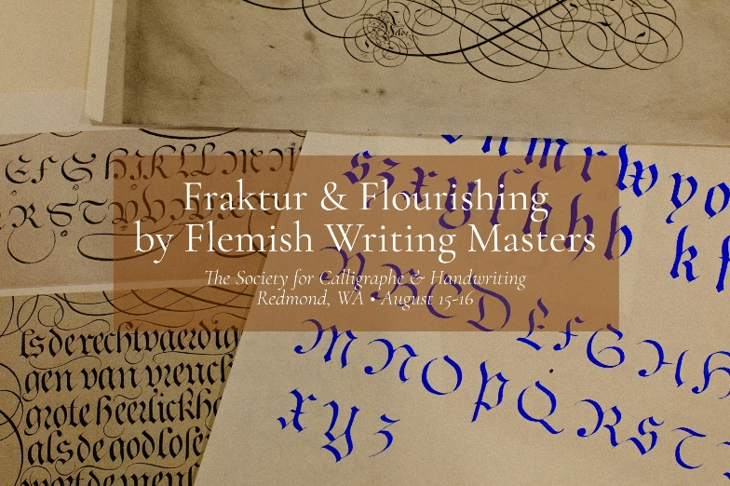
Fraktur calligraphy is often associated with German-speaking regions, but Flemish writing masters also played a significant role in shaping Gothic and Blackletter styles, including Fraktur and its related scripts. During the late Renaissance and Baroque periods, Flemish calligraphers were highly influential in the development of European writing styles, blending gothic traditions with more ornamental and expressive elements.
Jan van de Velde (c. 1568–1623) was a Dutch-Flemish calligrapher and writing master renowned for his Spieghel der Schrijfkonste (1605), one of the most influential calligraphy manuals of the early 17th century. While he is best known for his elegant cursive scripts, such as Cancelleresca (chancery cursive), he also demonstrated mastery of Fraktur, the intricate and angular blackletter script widely used in the Low Countries and Germany.
In this workshop we will explore the form of Fraktur by Flemish master, specially by Velde, with modern writing tools such as metal broad edge nib and pointed nib. Fraktur comes perfectly with the Roundhand & Italian Hand flourishing style.
Hoang Dao is an international calligrapher who is has appeared in trade publications like the Speedball Textbook, 25th edition, taught Romans and Foundational at IAMPETH, was the featured instructor at the Society of Gilders Conference 2026, and makes fine crafted pen holders since 2016. He chaired the first ever International Calligraphy Conference in Hanoi 2025 and continues to make his mark in the lettering and gilding world. To learn more about Hoang, go to www.huyhoangdao.com; IG: @huyhoangdao
In person and on Zoom. Recordings will be available for 3 months after the session. Priority will be given to SCH members. Fifteen in-person students max, and up to 30 total attendees with online students. Online students will be able to download handouts.

August 15-16, 2026; 9:30AM-4:30PM
18080 NE 68th St, Suite B160, Redmond, WA 98052
$130 members, $160 non-members, In person and on Zoom
Mail in registration to address above c/o Lisa Tsang, lisa.tsang@outlook.com
Check payable to SCH, or Zeffy at this link: https://www.zeffy.com/en-US/ticketing/sch-workshop-fraktur-and-flourishing-by-flemish-writing-masters (If making payment through Zeffy, they tack on an optional fee that you will need to change to $0 on the bottom of the drop down box during checkout if you don’t agree to that additional fee)
Sign up information on next page

Name ______________________________________________ Email _______________________________________

Address _________________________________________________________________________________________

SCH Member? Yes ____ No ____ 10-Digit Phone Number ___________________________________________

In Person ____ Zoom ____ I can bring a treat to share Saturday ____ Sunday _____

