  SCH Presents  Understanding Brush-Written Imperial Romans  By Paul Herrera  October 17-18, 2026 | 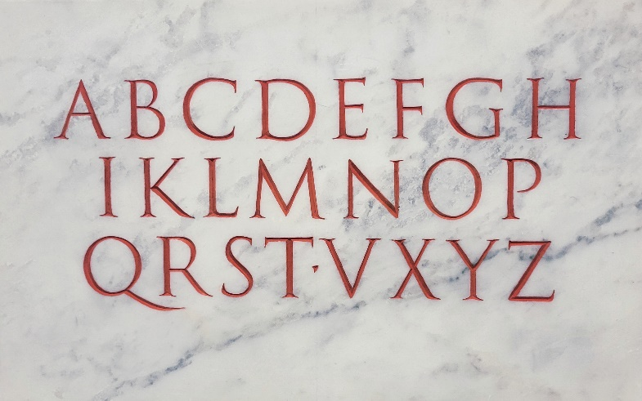
This workshop is a fast paced 2-day workshop on brush writing of the Imperial Roman Alphabet that will give you a hands-on understanding utilizing an inside-out approach of these letterforms. You will learn the special characteristics and “personality” of the brush as contrasted with hard-tool calligraphy while practicing the essential elements of the classical Roman. Before the workshop is done, you will write the entire alphabet in the same manner as the ancient Roman inscription maker would do prior to cutting the letters in stone.
A short inscription cutting demonstration will be provided as an addition to the class.
Paul Herrera is an authority on Roman capitals having trained first hand with Father Catich and authored “Rich Man, Poor Man, Priest: The Life and Times of Reverend Edward Michael Catich.” His half-scale replica of the Trajan inscription resides at the Letterform Archive in San Francisco and he recently taught inscription carving at the 2026 SLC IAMPETH conference to 45 students! He hosted the 2024 Roman Holiday International Conference at St. Ambrose University and continues to teach throughout the US. In his 40-year career, he strives to inspire the next generations in calligraphy. To learn more about Paul, go to YouTube’s Letterform Archive Lecture Series, http://paulherreracalligrapher.blogspot.com.
In person and on Zoom. Recordings will be available for 3 months after the session. Priority will be given to SCH members. Twenty-five in-person students max, and up to 50 total attendees with online students. Online students will be able to download handouts.

October 17-18, 2026; 9:30AM-4:30PM
18080 NE 68th St, Suite B160, Redmond, WA 98052
$100 members, $130 non-members, In person and on Zoom
Mail in registration to address above c/o Lisa Tsang, lisa.tsang@outlook.com
Check payable to SCH, or Zeffy at this link: https://www.zeffy.com/en-US/ticketing/understanding-brush-written-imperial-romans-with-paul-herrera (If making payment through Zeffy, they tack on an optional fee that you will need to change to $0 on the bottom of the drop down box during checkout if you don’t agree to that additional fee)
Sign up information on next page

Name ______________________________________________ Email _______________________________________

Address _________________________________________________________________________________________

SCH Member? Yes ____ No ____ 10-Digit Phone Number ___________________________________________

In Person ____ Zoom ____ I can bring a treat to share Saturday ____ Sunday _____

Places will be filled based on postmark date. Payment must accompany registration. If you sign up for the workshop but cannot attend and your place can be filled from the waiting list, you will receive a full refund minus administration fee of $10.00. If there is not a waiting list but you find a replacement for yourself, you will receive a full refund. If your place cannot be filled, your full registration may be retained to help cover the expense of the workshop. If the class must be cancelled, we will notify you and issue a full refund. All registrants will be notified of their status in the workshop two weeks prior.

